**User Management**

User management is one of the main tasks of Linux administrators . It involves creating, modifying and deleting the user account, as well as managing user permissions and access. Here the some basic commands related to user management:-

1. Add user:

This command is used to create a new user account.

here’s the syntax:-

**Sudo adduser <username>**

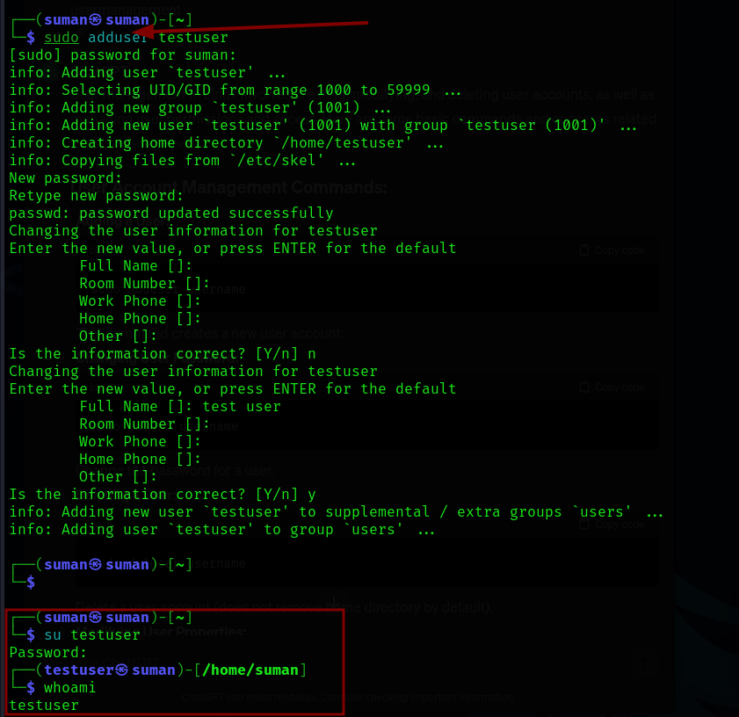

**Note:**

**whoami** is used to display the current username.

**su** command is used to switch user.

1. Changing user Password

Here the syntax to change the password of user:-

**sudo passwd <username>**

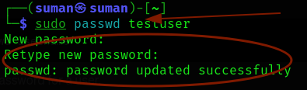

1. **Deleting the user:-**

To delete a user in linux weuse ‘userdel’ command. Here’s the example:-

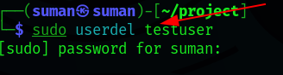

**Group management**

1. Adding a Group

Here the syntax to add a new group in linux:

**Sudo addgroup <groupname>**

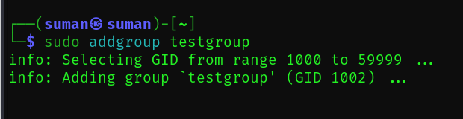

1. Adding existing user to a group:-

Here is the command add existing user in group :-

**sudo usermod -aG <groupname> <username>**

In this command -aG stand for “append to the group list”

Here the example to add a user named “testuser” to group named “testgroup” :-

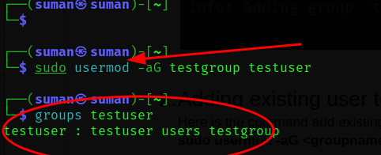

1. Deleting a Group:

Here is the command to delete group:-

**sudo delgroup <groupname>**

Here the example of deleting group i have created:-

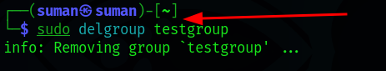

**File and Directory Permissions:**

1. **Change the ownership of a file or directory:-**

To change the ownership of a file or directory in linux, we use the ‘chown’ command . Here’s the basic syntax and example:

**sudo chown <desired owner:group or group ID> <file or directory>**

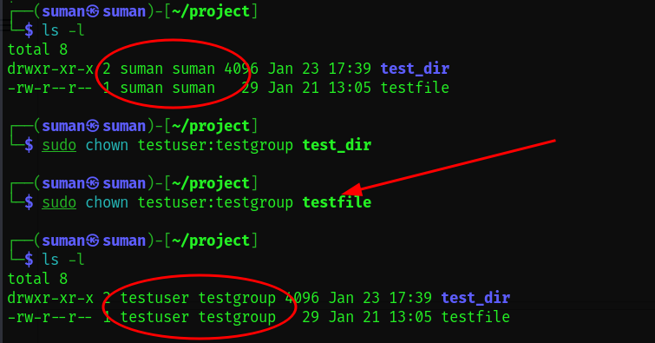

In this figure I have a directory named “test_dir” and a file named “testfile” . Initially, both were owned by the user ‘suman’ and the group ‘suman’.

After I use the “sudo chown” command to change the ownership of both ‘test_dir’ and ‘testfile’ to a new user named ‘testuser’ and a new group named ‘testgroup .

**Chmod**

Files and directories have associated permissions that define who can do what with them . Permission are represented by a series of letters and symbols, often displayed using ‘ls -l’ command . Here’s a brief explanation of file and directory permissions in linux:-

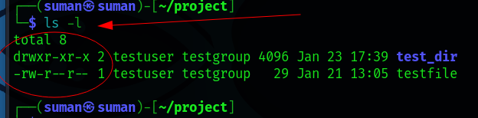

**a). In directories :**

**‘drwxr-xr-x’** :- this represent the type and permissions of the directory :-

**‘d’**  = directory

‘**rwx’** = permissions of the owner (testuser)

**‘r-x’** = permissions for the group (testgroup)

**‘r-x’**  = permissions for others

**b). In files:**

**‘-rw-r–r– 1** :-this represent the type and permissions of the directory :-

**‘-’** = file

**‘rw’** = permissions of the owner (testuser)

**‘r’** = permissions for the group (testgroup)

**‘r’** = opermissions for others

Here’s the detailed overview of symbolic and numeric representation in permission:-

**a). Symbolic Representation:-**

* r: Read
* w: Write
* x: Execute
* -: No permission

eg: if we need to change the file permission to read, write and execute to all (user, group and others) in symbolic we use this command:-

**sudo chmod u+rwx,g+rwx,o+rwx <filename>**

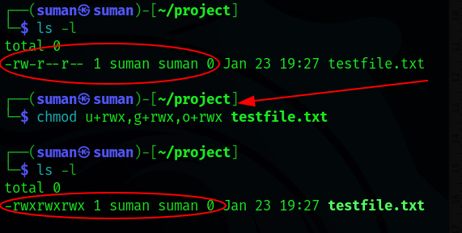

**b). Numeric Representation:-**

* 4: Read
* 2: Write
* 1: Execute

eg: if we need to change the file permission to read, write and execute to all (user, group and others) in numeric we use this command:-

**sudo chmod 777 <filename>**

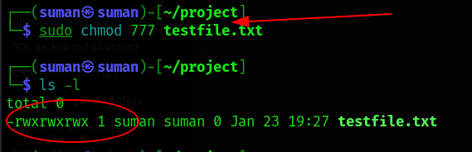

**Chown**

The **‘chown’** command is use to changes the owner or group of file or directory . Here is the basic syntax and example of chown:-

**sudo chown <owner:group> <file_or_dir_>**

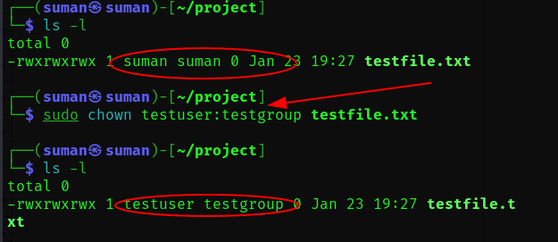

**Chgrp**

The **‘chgrp’** command is specially used to change the group ownership of a file or directory . Here is the basic syntax and example:-

**sudo chgrp <group name > <file_or_dir>**

This command changes the ownership of ‘testfile.txt’ to the group ‘prod_group’

